Paddy Hayes OOP Project Documentation

# Requirement Specification:

For my OOP project I decided to make a Slot Machine. The way the slot machine works is that you click the coin to put it into the machine. While there is a coin the machine you will can click the lever so it will go down and will take away a coin in the slot machine. The slot machine will then pick a random number which will be linked to an image which will then appear on the reel. If you get three kronks you lose and game “breaks”. If you get three bananas Donkey kong appears. If you get three 7s you win.

Public class SlotMachineGUI create the GUI and extends and is creating the instance of SlotMachineMethods. The public SlotMachineGui creates a new form called SlotMachineGui. Random Randy creates the random number generator. The slotMachinebtnActionPerformed will perform an action when the slotMachinebtn is clicked. The catch exception catches the exception. SlotMachineMethods is constructing the player money the file and the score. The public void addMoney will add money to the player balance. The public void takeMoney wil take money from player balance.

# UML Diagram:

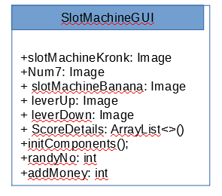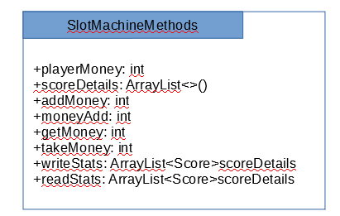

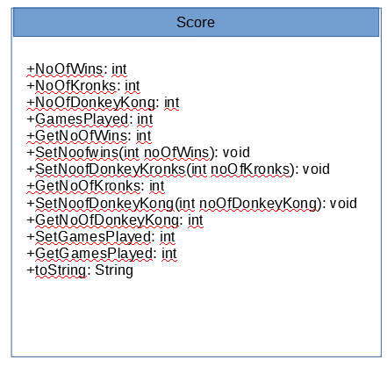 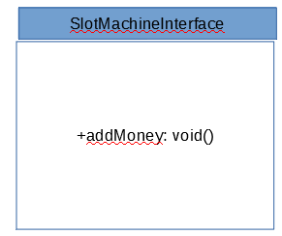

# VOPC Diagram:



